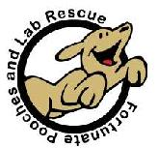
Fortunate Pooches and
Lab Rescue

Spring 2006 Edition
Who We Are
We are a small not-for-profit rescue in Northern Illinois. We are dedicated to those labs and lab mixes in need of our help. When pooches, especially labs, are up to be euthanized we try to step in and, help as much as we can. When we take a lab or lab mix in we find a foster home and wait for the perfect family to adopt our four-legged friend.
In addition to rescues we keep our pooches up to date on their shots. All of our friends receive a checkup, and their basic vaccinations from a veterinarian. Also our dogs are micro chipped and spayed/neutered. All the donations that are given help every bit. And all donations are used to pay for the food and medical care for our fortunate pooches.
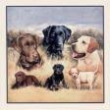

A Happy Ending
Wiley (Shepard mix), rescued from a rural Illinois shelter, and Peaches (black lab); rescued from the Katrina region, now snuggle together as a happy brother and sister in the Steinberg Family.

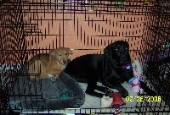

The creator of this newsletter
My name is Alysa Goeke, and I am 13 years old and am currently going to 7th grade at Cass Junior High School. My favorite thing to do is spending time with animals especially with my dog Roxy. I also helped out at a North Carolina No-Kill shelter walking and taking care of the dogs. I loved every minute I spent with the dogs the whole week we were there visiting. I’ve had lots of experience with animals and I am glad to be on the lab rescue team.

A Saved Life!

Sweet Valentine (shown above and at left in photo of sleeping labs) was a starving and heartworm-infested refugee from the Katrina disaster. Look at this beautiful blonde boy now! He also has a new big sister, Brandy (she's a Fortunate Pooches alum too!), to share a lazy snooze with, and a wonderful home and new life with the Pomerance-Fine Family.

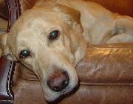

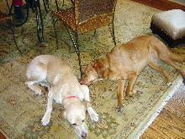



Petco and Petsmart Save the Day

Please come visit our pooches. Special thanks to Petsmart and Petco for letting us show our much loved companions with the community.

Volunteers Needed
FPALR needs volunteers if we want to keep saving lives of labs and lab mixes.
We need:
-Transporters to pick up our dogs and bring them to the vet.
-Dog Walkers to exercise the dogs.
-Home Visitors to look over the homes of interested adopters.
-Foster Homes to help move recently rescued labs from the shelter to a home lifestyle experience.
-Event People to work the adoption events on weekends, greeting visitors, taking applications, and showing dogs.

Please stop at our events and look at our website for our shelter FPALR.

HELP DOGS STAY COOL LIKE THIS!
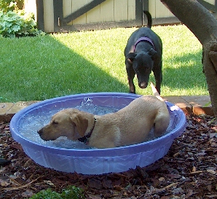
Dogs on Damen Adoption Event

May 20-21

We’ll be showing off our adorable, adoptable dogs at a multiple-shelter adoption showcase at Lincoln Park Savings Bank, located at 4035 N. Damen in Chicago. More details to follow, but if you'd like to help us with this event, please send us an email!

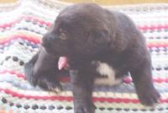

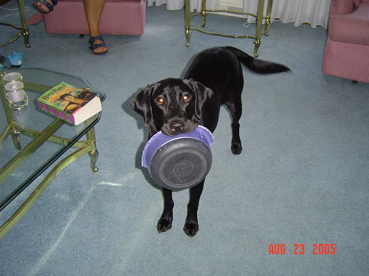
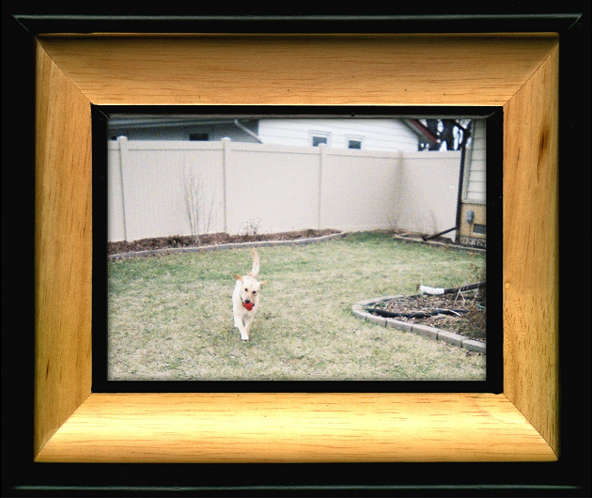
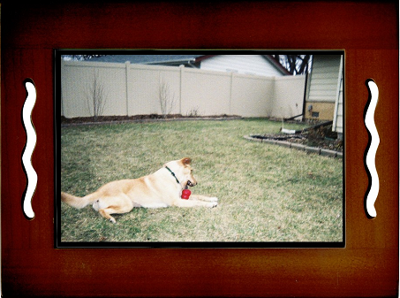
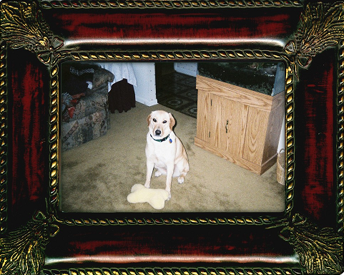

FPALR, Inc. gives thanks to Bella's Dad, Allen T. Wojtas for all his time and generous work in support of the rescue. Bella, a black lab female passed away at a young age suddenly of an auto immune disease. We miss you Bella, and we hope that you will change the world from up above. Animals in many cases watch from above the human behavior without spoken words. Passed away on September
2005.

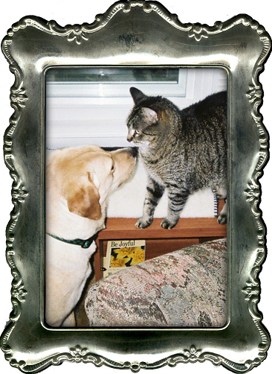


Josie comes from Fulton County Humane Society in Illinois, and she was going to be euthanized because her owners had no time for her and because she did not like other dogs. Well Josie and her dad foster for FPALR,INC. now and she goes to the doggy park.

Some of our 4-legged friends needing homes
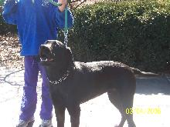
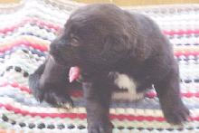
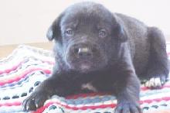
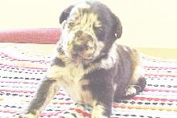

Hercules

Sam
Bart
Todd
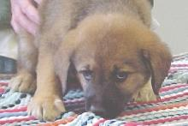
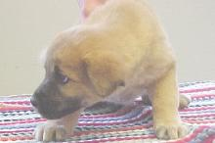
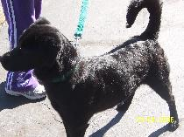
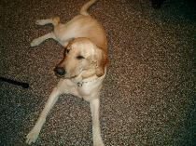

Roger
Daisy
Bijou
Bubba

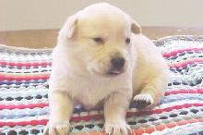
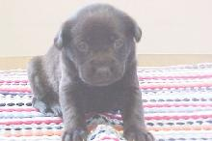
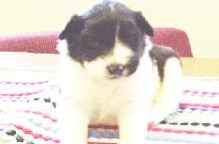
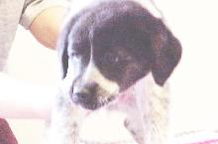

Polly
Midnight
Molly
Little Girl 1

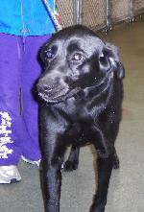
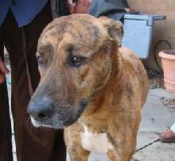

Beau

Ruby

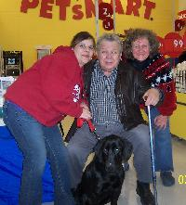
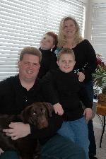
A match made in heaven

This is how Suzanne Rohlfing describes her parents' relationship with new adoptive lab, Maggie. Maggie, formerly known as Jessie, was rescued from the Katrina disaster but had a seriously injured back leg that required expensive therapy. After reading about our injured dogs in the Daily Herald, the Tomek family of Wheaton made a generous donation to help pay our dogs' medical bills. Once they actually met the former Jessie at a Petsmart adoption event, it was love at first sight. Shown with Maggie are (left to right) Ileana Pullos, founder of Fortunate Pooches and Lab Rescue, and two members of Maggie's new family, George Tomek and his daughter Suzanne.
A PERFECT FAMILY

"Thank you for bringing Chase into our lives! He loves to cuddle, he is obedient, and he is a perfect fit for our family."
Chase, a handsome chocolate Labrador retriever came from a high-kill shelter in Ohio. And just like Eddy, another chocolate Labrador retriever pictured below, they found their perfect families. These stories touch our hearts, and make our rescue work much more fun and rewarding! Thank you to all of our GREAT ADOPTERS!!!

Best Friends 4 Ever!

Josie is from Fulton Humane Society. She has been happily adopted to a great home. Her new dad spoils her, plays with her, and trains her. Josie loves her new cat friend and they are best buddies!

Beloved Friends

Mathew and Eddy (little dog-child rescued from Missouri) are now sleeping, very content and happy, that Liz (rescued from Mississippi) and Xena (rescued from Louisiana) are now safe too.

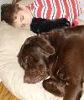
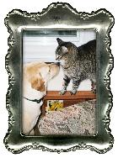

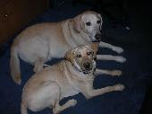

Another Saved Life!

Hannah comes from Logan County Animal Control in Lincoln, IL. From a very compassionate Animal Control Warden. Due to changes in policies and the fact that the board dictated for most dogs to be euthanized, the animal warden has quit.

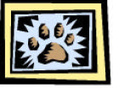
Give ‘am a Paw-they’re
ADOPTED!!!
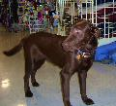
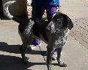
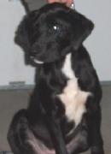

Chuckie
Godiva
Oscar

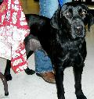
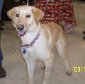
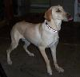

Isabella
Cream
Lacota

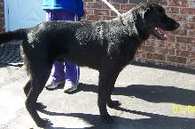
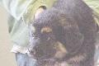
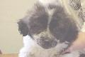
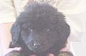

Gunnar
Little Girl 2
Little Boy 2
Harley

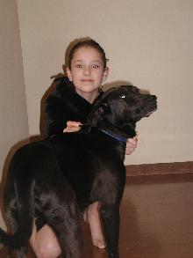
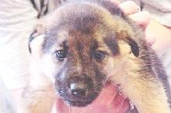
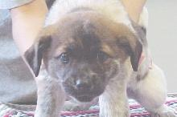
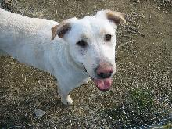

Little Boy 1
Little Boy 3
Derby
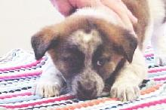

Seven

Little Girl 3

More Adopted dogs
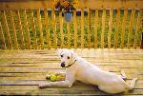
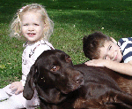
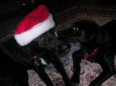

It cannot get better than this!

Just lounging!hmmm???
Xena, You must behave!

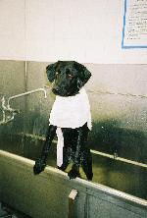
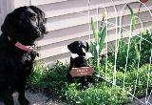
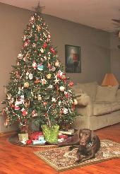

Zoe here! I love baths.
Pretty Lilly and her friend

I am soooo pretty and well behaved!

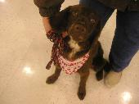
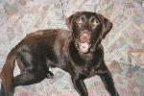
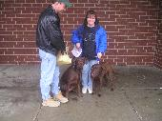

Morgan from DeWitt AC

Ruby found her forever home!
Penny enjoying her play time!

Hickory and new family...Lucky Me!

Charlotte old news...now Molly, and I am in style
Hello, I am Mac!

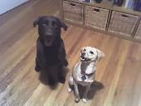
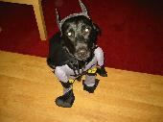
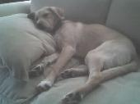

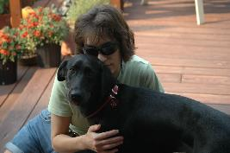
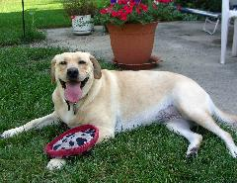
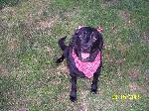
I look up to him! Bailie& Choco
I am the rescue King! CJ
You caught me!!! I see you....!

This story started out with a dog named Snooker (Changed to Jacko) that was abandoned and taken by a family that loves him more than anything. Written by Sandra.

When I saw the picture of Jacko (then Snooker) on www.petfinder.com which is how I found Fortunate Pooches and Labs, I fell in love with him!! His long ears and knowing/naughty look, I immediately phoned FPALR to ask if he was still there. Fortunately (no pun intended) he was and we decided to adopt him without hesitating and named him Jacko. He was about a year old. He had been dumped at a vet in Iowa and the vet's assistant did not want Jacko to get put down so she started calling rescues hoping somebody would take him in and was lucky enough to contact FPALR who said they would give him another chance.
Jacko is really smart and when we had the electric fence put in, he soon worked it out and only got "zapped" once - after that he knew where he could go. We often get comments about what a great-looking dog he is as there aren't many Coons in the Mid West. He's an English Red-tick Coonhound. He loves to play, especially with squeaky toys which he pretends are possums. At the dog park he's extremely social and never fights or harasses other dogs. There he can run off all the abundant energy he has. He also loves going for hikes with us, the longer the better! He's very loving and enjoys leaning on you when you cuddle him but he's also a tough dog when defending his property from squirrels. He doesn't bay much, only from time to time when we're not home according to our neighbors - he doesn't like it when he's left home alone. He absolutely adores kids and they adore Jacko and his long ears.
